**Figure S1.** Prolonged, but not acute morphine decreases diurnal variations in circadian behavioral activity. **(A)** Control (n=14-15) mice increase their locomotor activity in the light phase, while McKO (n=9-10) littermates decrease their locomotor activity in the light phase following repeated morphine exposure (with no change in the MKO regardless of phase or experimental day) . Three-way ANOVA with a Holm-Bonferroni post-hoc adjustment performed on all pairwise comparisons. **(B)** Controland McKO mice exhibit a decrease in diurnal variations in circadian activity, whereas MKO (n=7) animals do not. Two-way ANOVA with a Holm-Bonferroni post-hoc adjustment performed on all pairwise comparisons (#p<0.05, *p<0.01, **p<0.001, ***=p<0.0001). Data presented as mean ± SEM.

**Figure S2.** All genotypes retain normal behavioral activity patterns throughout the course of the morphine treatment paradigm. Three-way ANOVA by phase x genotype x experimental day (#p<0.05, *p<0.01, **p<0.001, ***=p<0.0001). Data presented as mean ± SEM.

**Figure S3.** Protracted morphine exposure causes morphine-induced behavioral sensitization in Control, but not McKO or MKO mice. **(A)** & **(B)** Control mice (n=14-15) treated with chronic morphine exhibit morphine-induced behavioral activation 2-3 hours following a 20 mg/kg i.p. morphine injection at ZT0 and ZT12. **(C)** & **(D)** McKO mice (n=9-10) treated with morphine exhibit no change in morphine-induced behavioral activation 2-3 hours following a 20 mg/kg i.p. morphine injection at ZT0 and ZT12. (**E)** & **(F)** MKO mice (n=7) treated with morphine exhibit no morphine-induced behavioral activation 2-3 hours following a 20 mg/kg i.p. morphine injection at ZT0 and ZT12. Three-way ANOVA (phase x genotype x experimental day) with a Holm-Bonferroni post-hoc adjustment performed on all pairwise comparisons. (**p<0.001, ***=p<0.0001). Timing of injections indicated by the white arrows. Data presented as mean ± SEM.

**Figure S4.** Prolonged, but not acute morphine decreases body temperature in control, McKO and MKO mice. **(A)** Mice treated with morphine for an extended period of time have decreases in average body temperature, except for MKO mice during the dark phase. Three-way ANOVA with a Holm-Bonferroni post-hoc adjustment performed on all pairwise comparisons. **(B)** Control (n=14-15) and McKO (n=9-10) mice exhibit a decrease in diurnal variations in body temperature following chronic morphine exposure, whereas KO (n=7) animals do not. Two-way ANOVA with a Holm-Bonferroni post-hoc adjustment performed on all pairwise comparisons (#p<0.05, *p<0.01, **p<0.001, ***=p<0.0001). Data presented as mean ± SEM.

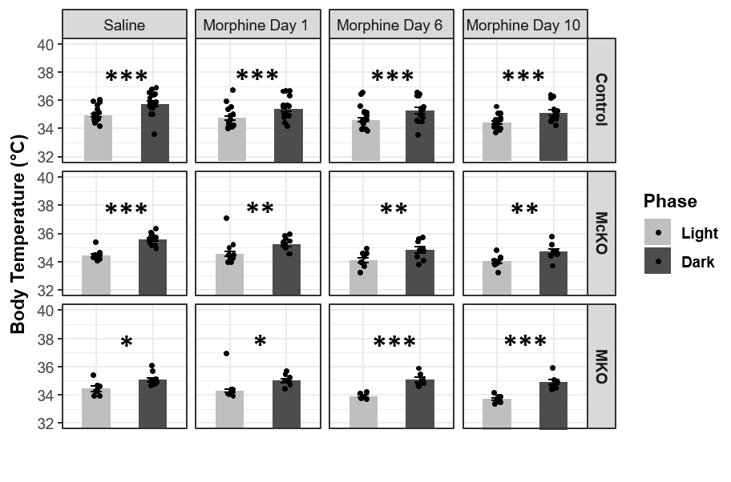

**Figure S5.** All genotypes retain normal body temperature patterns throughout the course of the morphine treatment paradigm. Three-way ANOVA by phase x genotype x experimental day (#p<0.05, *p<0.01, **p<0.001, ***=p<0.0001). Data presented as mean ± SEM.

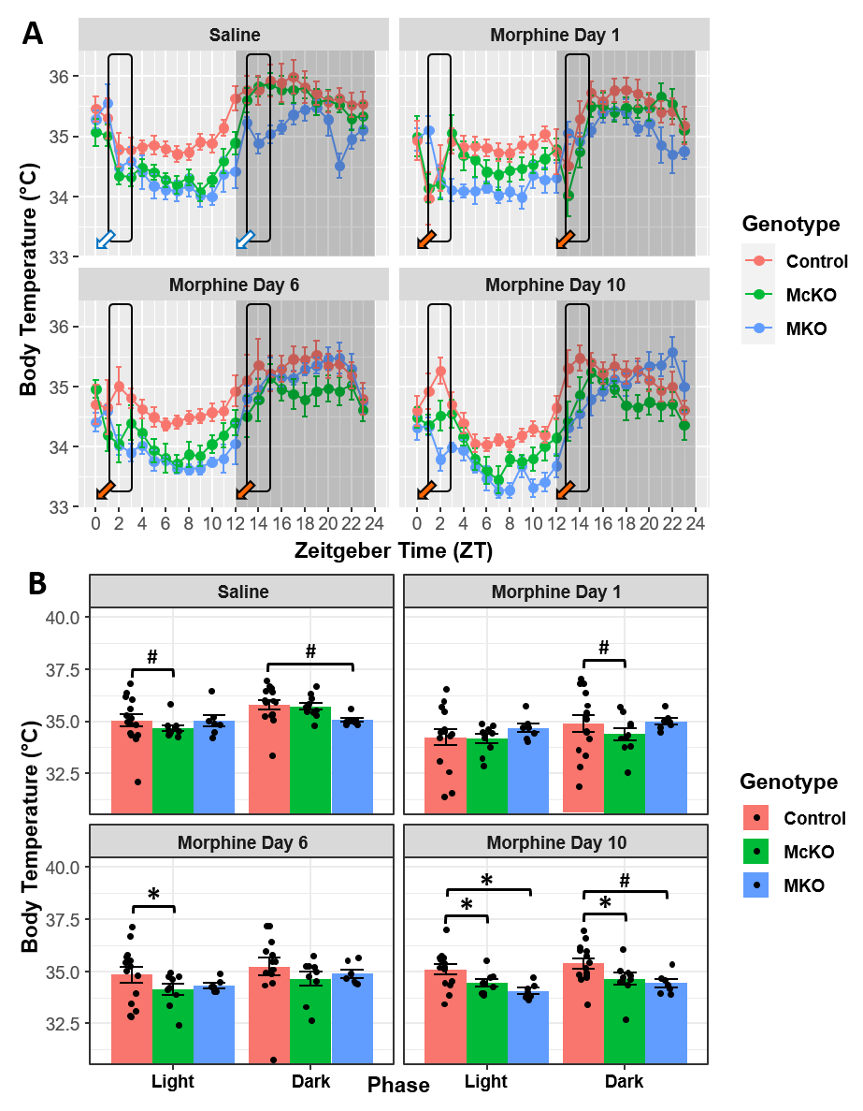

**Figure S6.** Mice that differentially express the MOR show body temperature changes in response to injections at different stages of a chronic morphine paradigm. **(A)** Following chronic morphine exposure, control (n=14-15) mice have a post-injection body temperature compared to McKO (n=9-10) littermates and age-matched MKO mice (n=7) following a 20 mg/kg i.p. morphine injection at ZT 0 and ZT 12. Arrows indicate time of i.p. injection with either saline (white arrows) or 20 mg/kg morphine (orange arrows). **(B)** Quantification of locomotor activity 2-3 hours following injections at ZT0 and ZT12. Three-way ANOVA with a Holm-Bonferroni post-hoc adjustment performed on all pairwise comparisons (#p<0.05, *p<0.01, **p<0.001, ***=p<0.0001). Data presented as mean ± SEM.

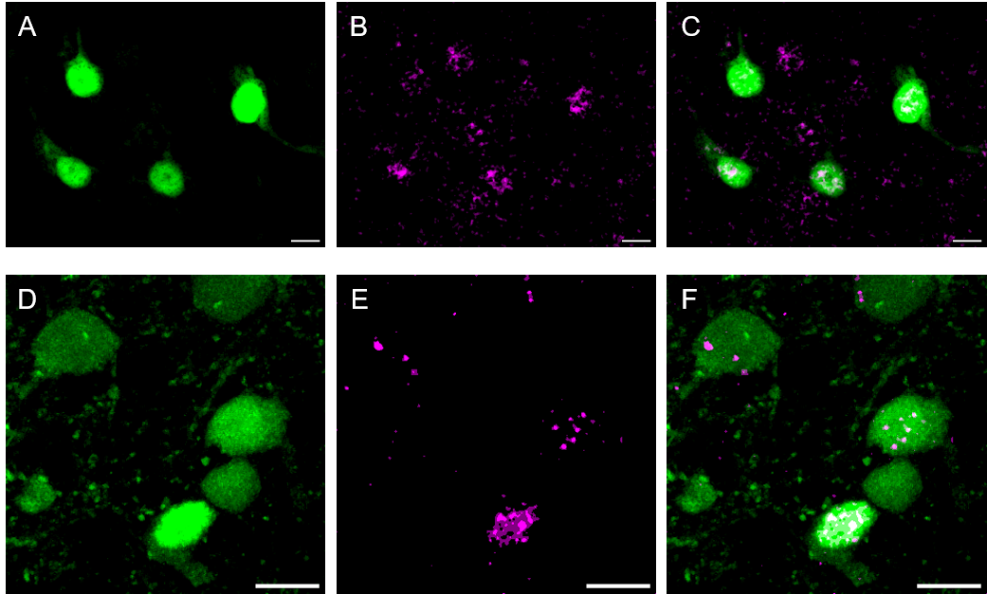

**Figure S7.** Positive controls show somatic Cre immunolabeling. **A-C**) Whole-mount retina from a McKO x *Opn4*-EGFP mouse. **A)** Native GFP signal, **B)** Cre antibody labeling (psuedocolored),and **C)** composite image of the maximum projection of all z-stacks containing the cells of interest. **D-F**) *Gal*-cre-tdTomato brain slice containing the preoptic area of the hypothalamus. **D)** Native tdTomato signal (pseudocolored), **E)** Cre antibody labeling (psuedocolored),and **F)** composite image of the maximum projection of all z-stacks containing the cells of interest. Scale bars = 10 μm.

**Figure S8.** Cre immunolabeling in the McKO brain may originate from EGFP+ ipRGCs. Sections containing the ventrolateral preoptic area of the hypothalamus **(A-C)**, caudate putamen **(D-F)**, and paraventricular nucleus of the thalamus **(G-I**). Single optical sections showing DAPI nuclear stain (pseudocolored) **(A, D, G)** and Cre antibody labeling **(B, E, H)**. Composite images of single optical sections **(C, F, I**) reveal Cre immunoreactivity primarily on the surface of (i.e. surrounding) cells. Scale bars = 10 μm.